THE COW SHED CRAIL ACCOMMODATION FOR UP TO 60

We are delighted to be able to offer accommodation packages to couples booking The Cow Shed. The properties can sleep up to 50 guests across our cottages, the farmhouse and our two converted shipping containers known as Cow Pads. The Cow Pads are available for one night stays and are separate to the packages listed below as they have less facilities available. To view and book the Cow Pads please go to www.eastcoastcabinco.co.uk

We require a 25% deposit to book the accommodation packages and the final balance is due 10 weeks before your stay. Key code entry is used for the cottages and will be provided to you by The Cow Shed. Check in is from 4pm and check out is from 10am. The cottages are managed through a company called Kingask St Andrews, however if you would like to book these as a package then we can do this on your behalf. If guests would like to book an individual cottage then this can be done directly online.

PACKAGE COSTS

The Cow Shed Cottages comprise of 4 cottages which can sleep 20 people and are located next to the venue, only a 2 minute walk away.

The Kirkmay Cottages are still on the farm grounds and only 0.4 miles away from the venue, a 10 minute walk (there is no lighting and the farm road can be muddy in wet weather) or short drive on a farm track. They comprise of 5 cottages and can sleep 21. From September 2025 two of these cottages will be on a long let so we will only be able to offer 3 cottages sleeping 12 at this site.

Sypsies Farmhouse is located right next to the Cow Shed and is available from 2023. It is a modern farmhouse with sea views, open plan kitchen living area with large garden. Sleeps 14. We can offer a 20% discount on the farmhouse for the off peak months of Jan, Feb, Nov and Dec (excluding Christmas and New Year).

Please note that in 2024 any bookings of the cottages and farmhouse have a 3 night minimum stay, however from the start of 2025 we now offer a 2 night minimum stay.

 | 2025 (price for 2 night min stay) | 2026 (price for 2 night min stay) | 2027 (price for 2 night min stay)
Cow Shed Cottages | £3900 | £4330 | Honouring 2026 prices for any bookings made by 31st Jan 2025.
Kirkmay Cottages | £3400 (until end Aug 2025)  £1990 from Sept 2025 due to 3 cottages instead of 5. | £2210 | Honouring 2026 prices for any bookings made by 31st Jan 2025.
Sypsies Farmhouse | £3500 | £3750 | Honouring 2026 prices for any bookings made by 31st Jan 2025.

Check out after your two night stay is not until 3pm, allowing you plenty time to enjoy your day (and have that lie in after the night before).

All prices include utiliites, wifi (please note that the internet connection can be slow due to the rural location of the cottages), linen and towels. We also have private parking for all houses and certain ‘extras’ like cots and highchairs which can be added on for a small fee. The cottages are all pet friendly however we do add on a small charge for dogs to help with the cleaning costs.

THIRD NIGHT STAY OFFER – if you would like to add on a third night stay then this can be added on for a small fee. To add on a third night to the farmhouse is an extra £250 and for each cottage it is an extra £50 per cottage. For any nights beyond a three night stay please enquire for details.

ACCOMMODATION CONFIGURATIONS

Sypsies Farmhouse (next to The Cow Shed venue):

Beautiful detached farmhouse with sea views from every room, sleeping up to 14 guests in 6 bedrooms (one is a double sofa bed). Open plan kitchen/living/dining room with folding sliding doors to the patio and garden. One other reception room. 10 min walk to Crail.

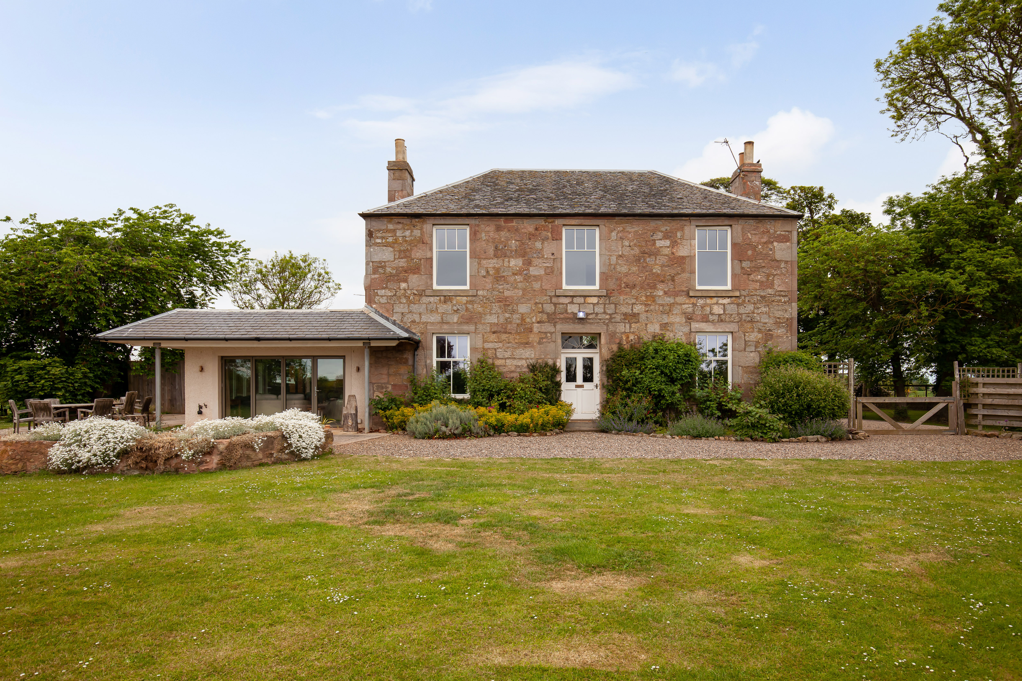

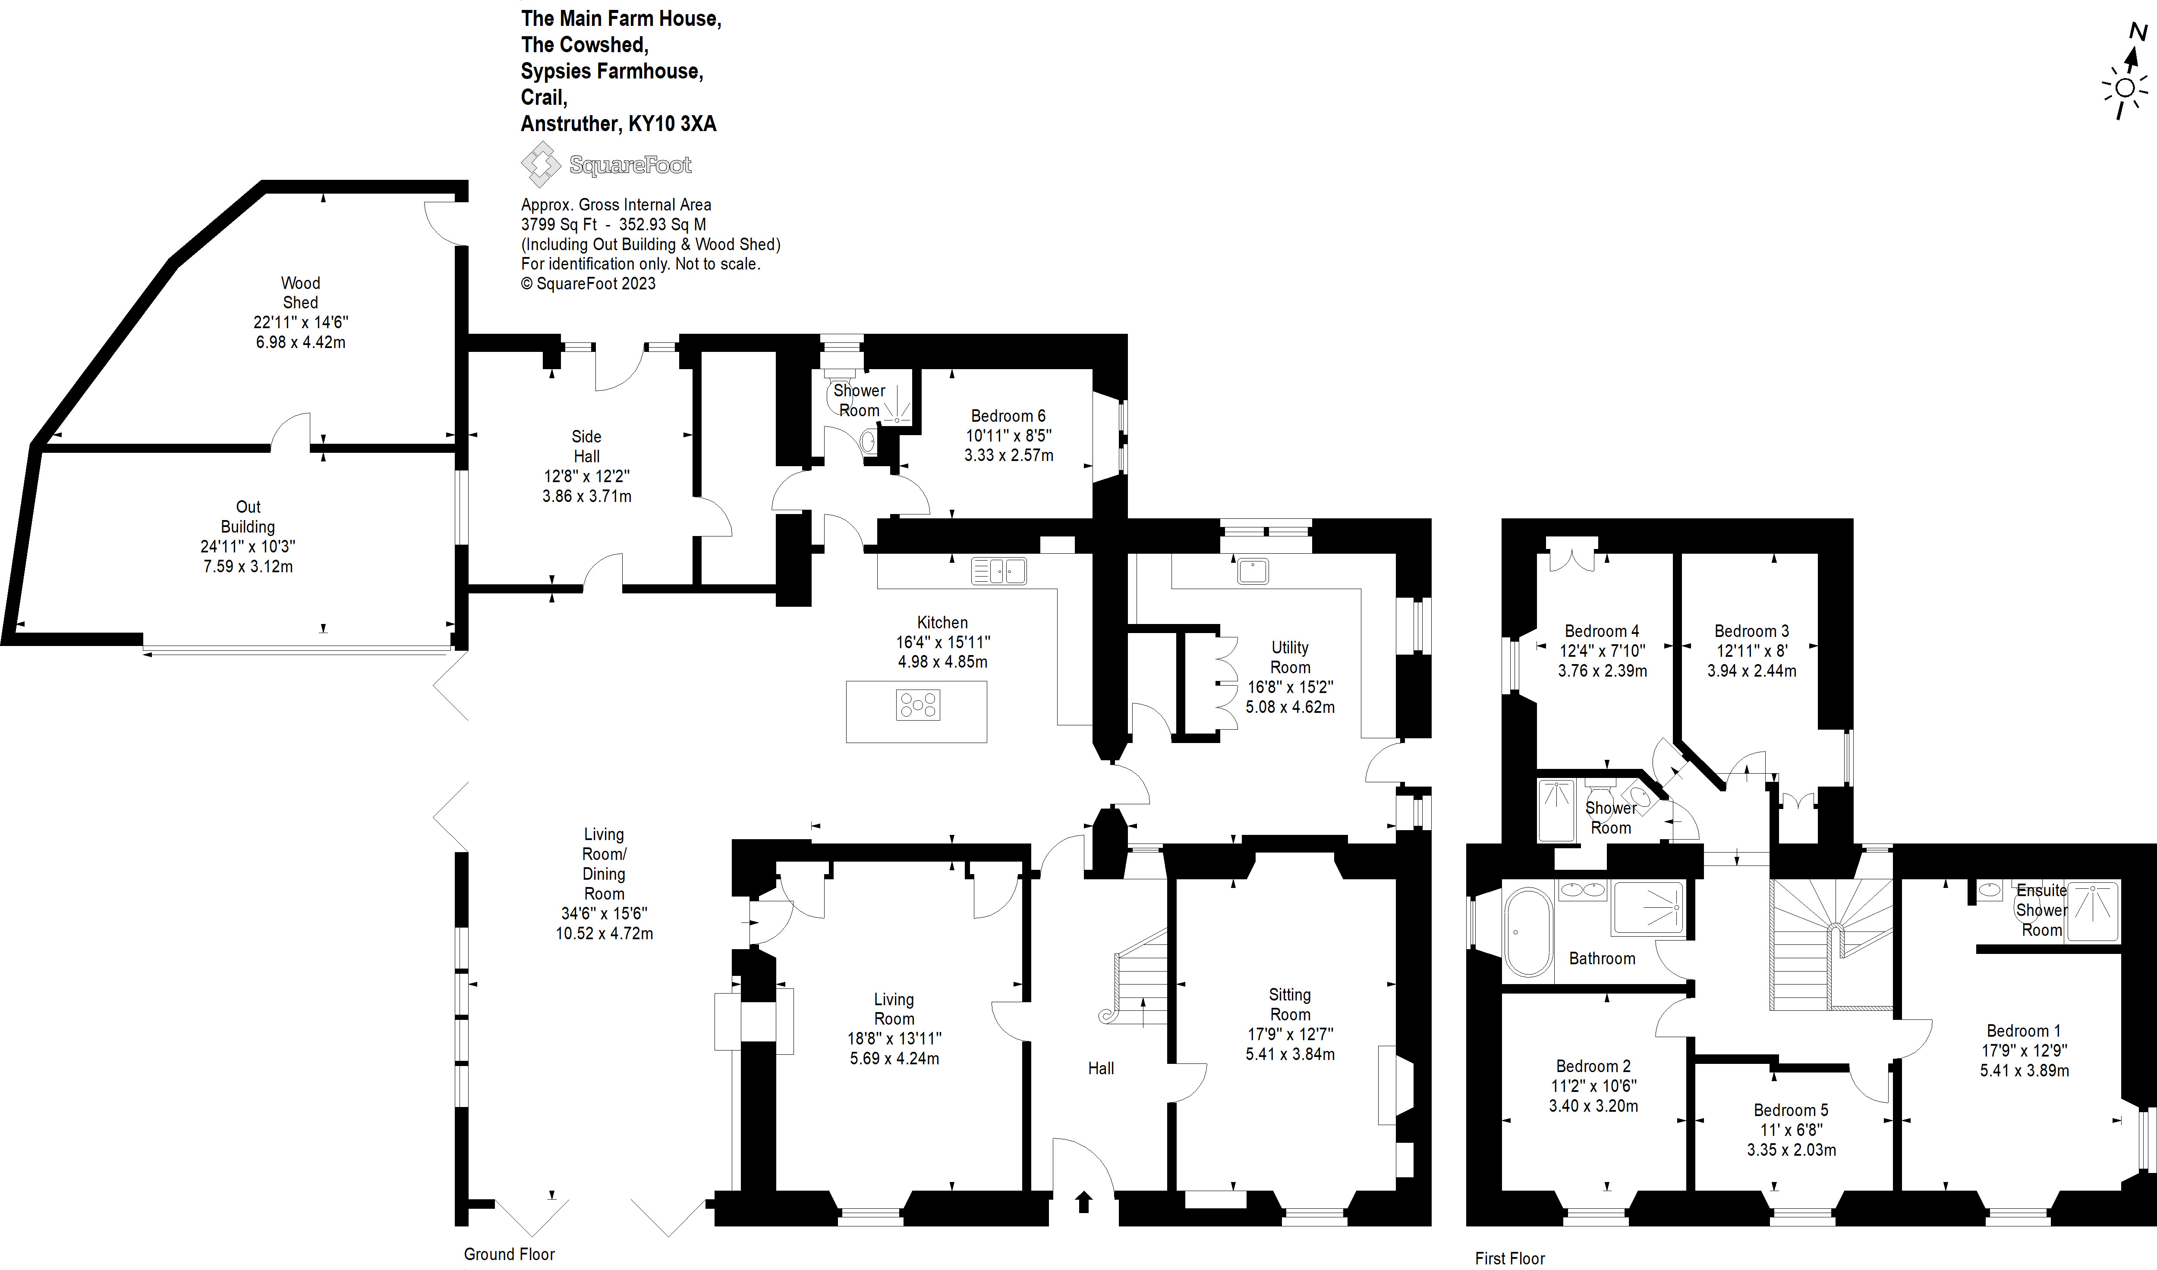

The Cow Shed Cottages (closest to the venue):

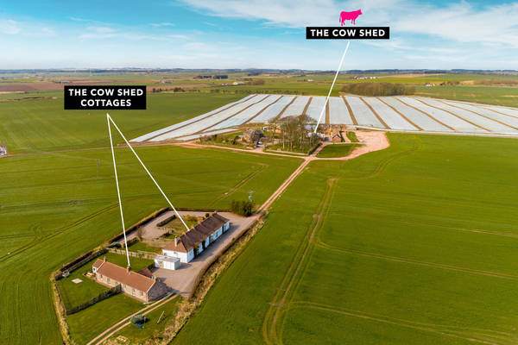
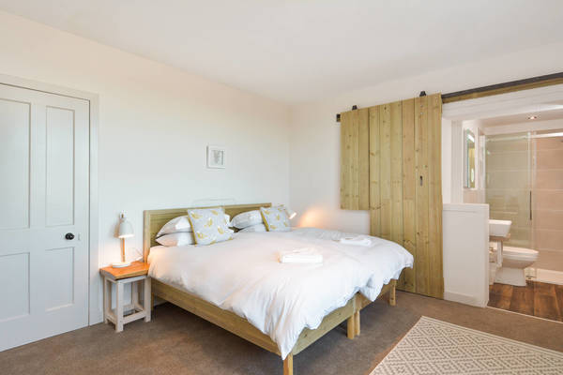

Meggie Allans

Sleeps 4 in one double room and one twin room
http://www.propertystandrews.co.uk/property-details/Meggie_Allans_Crail-74041/

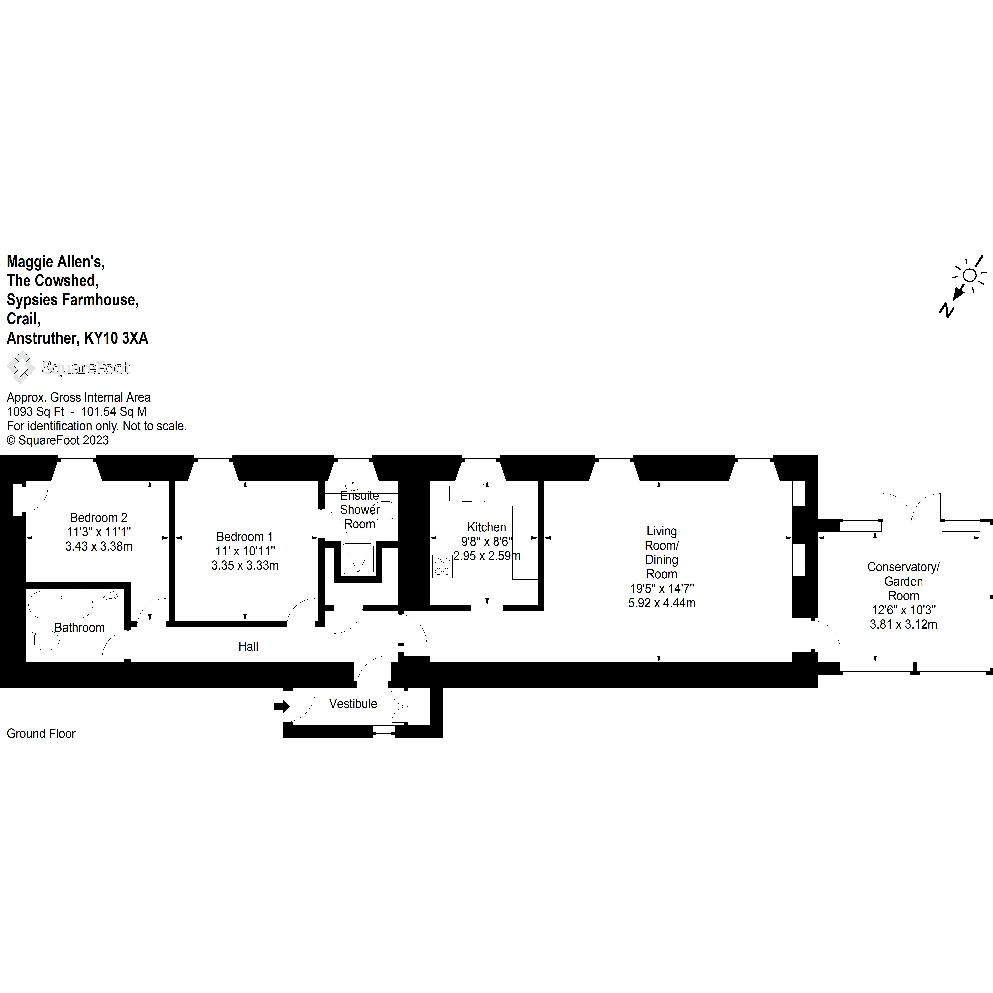

Cradle Cottage

Sleeps 4 in one double room and one twin room
http://www.propertystandrews.co.uk/property-details/Cradle_Cottage_Crail-74045/

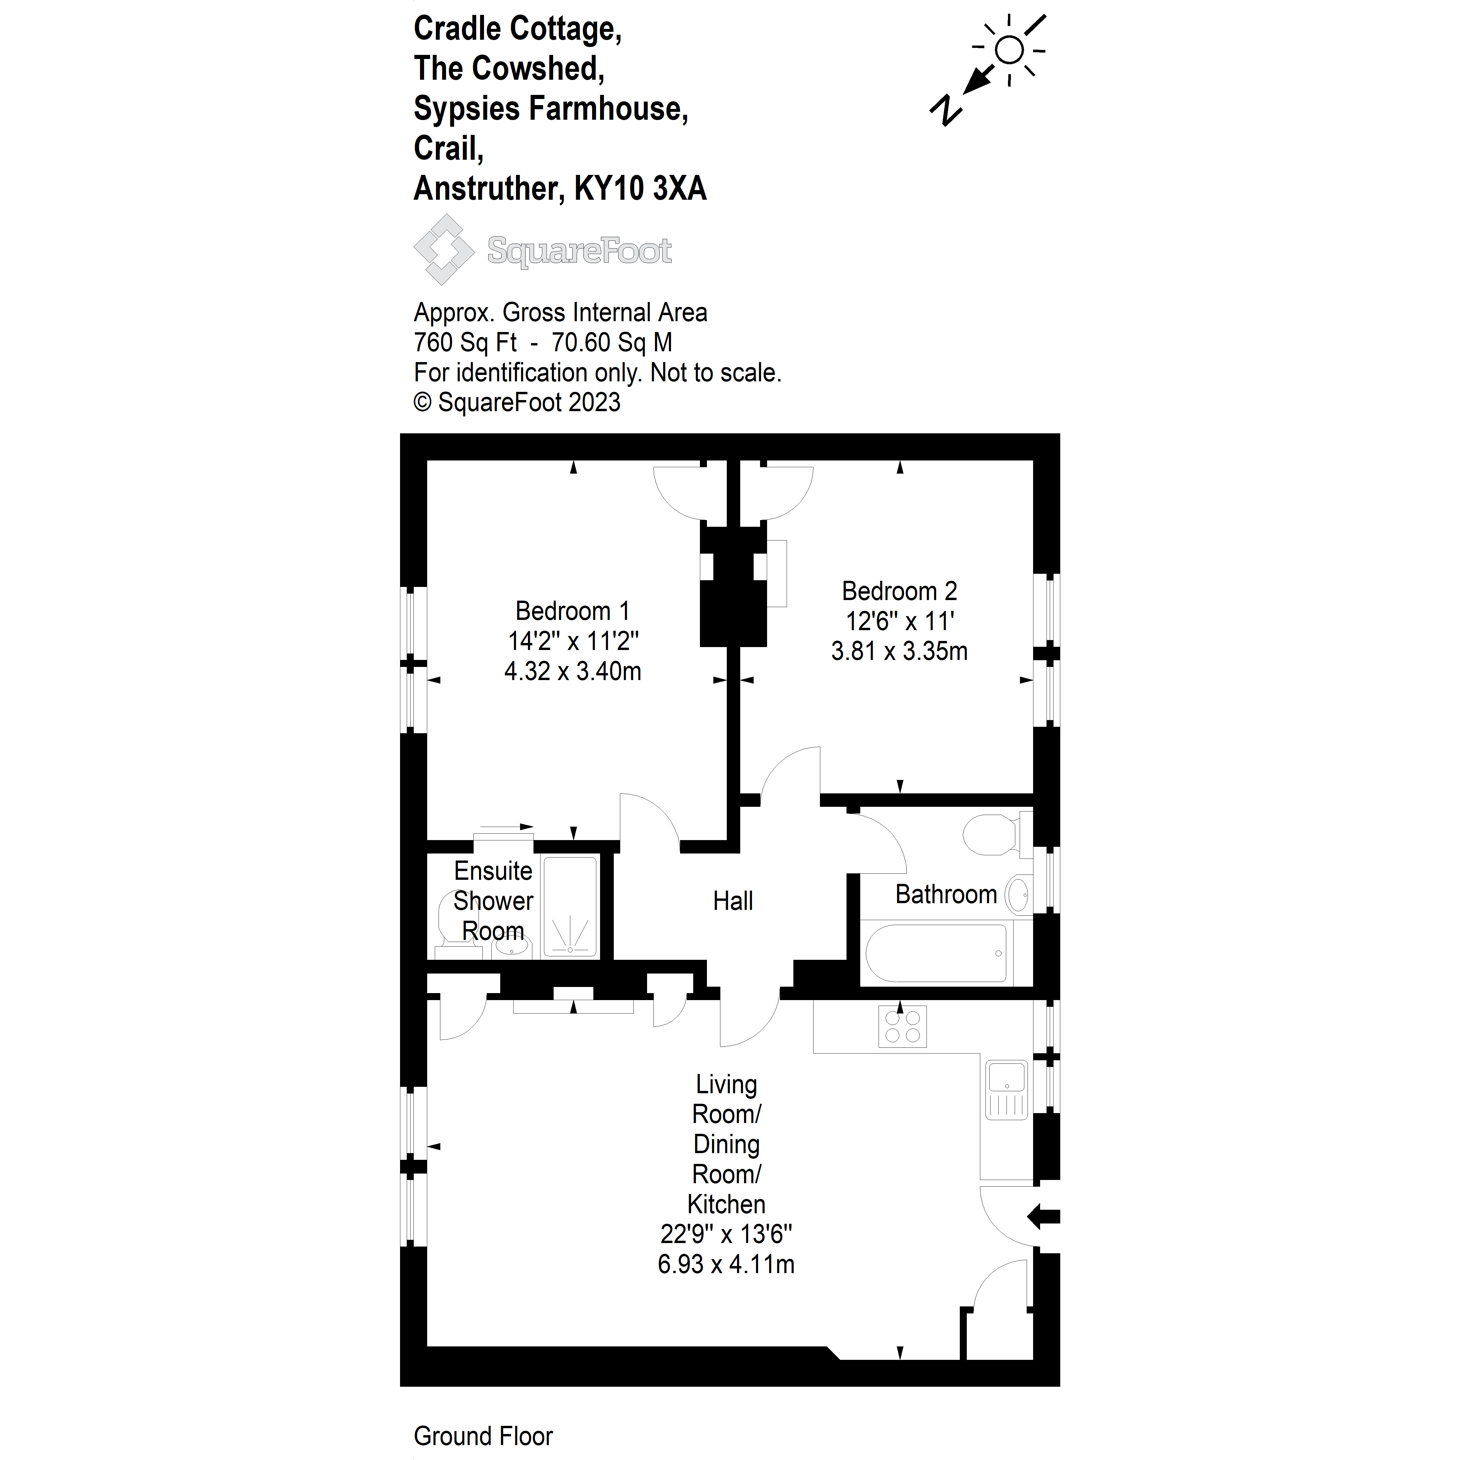

Sypsies Cottage

Sleeps 4 in one double room and one twin room
http://www.propertystandrews.co.uk/property-details/Sypsies_Cottage_Crail-74047/

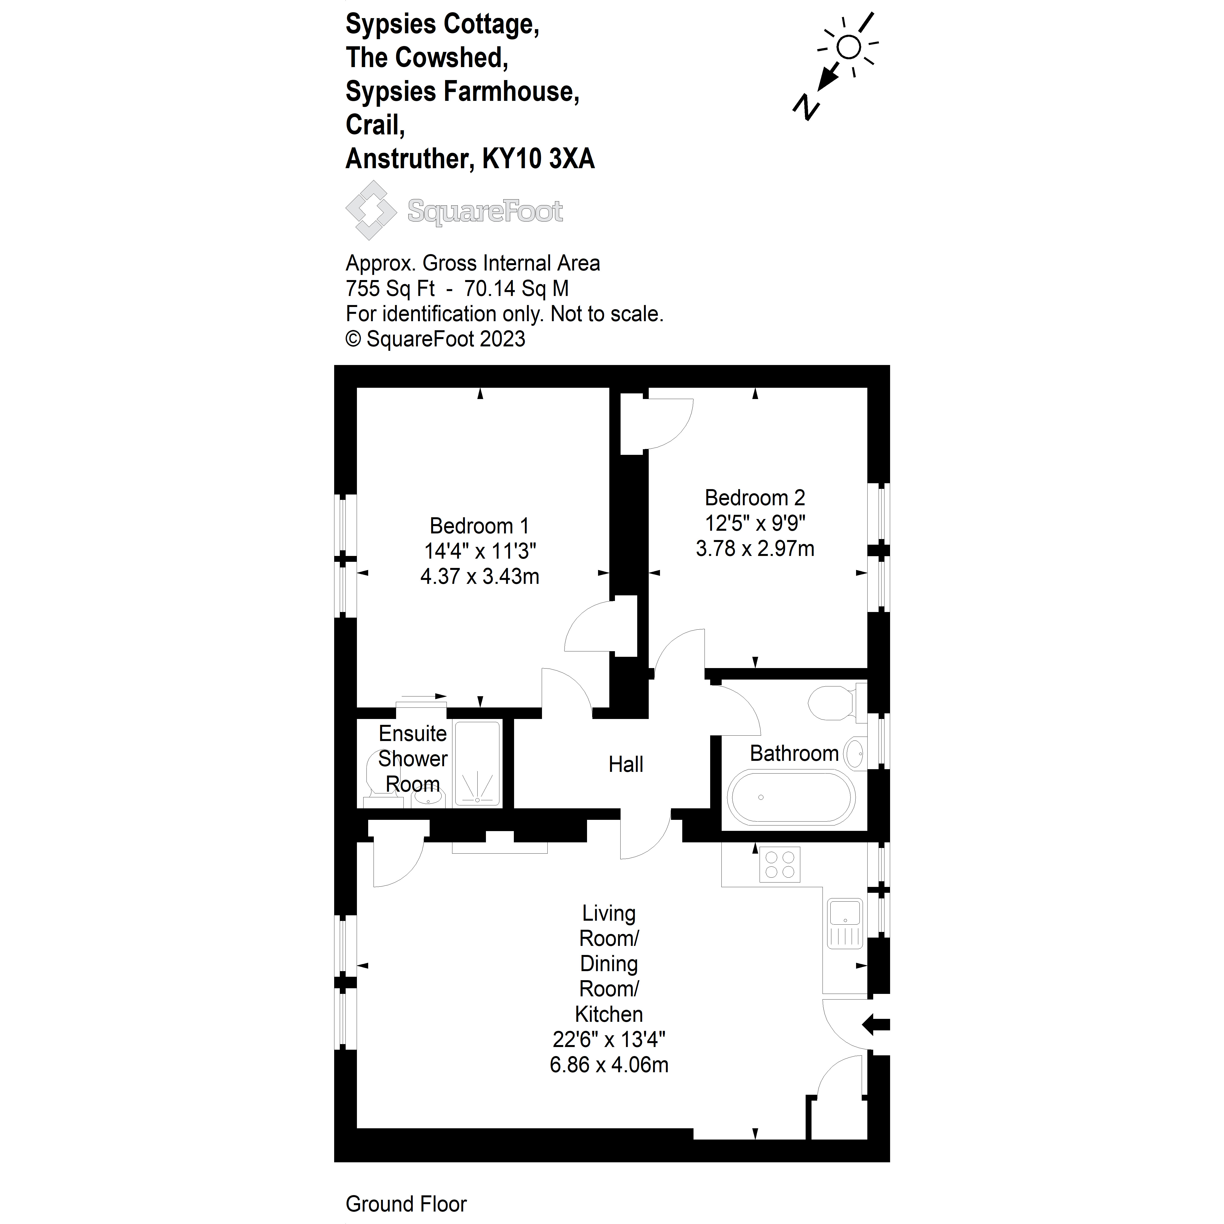

Mick’s Cottage

Sleeps 10 in one double room, 3 twin rooms and 1 sofa bed
http://propertystandrews.co.uk/property-details/Micks_Place__Crail_-521789/

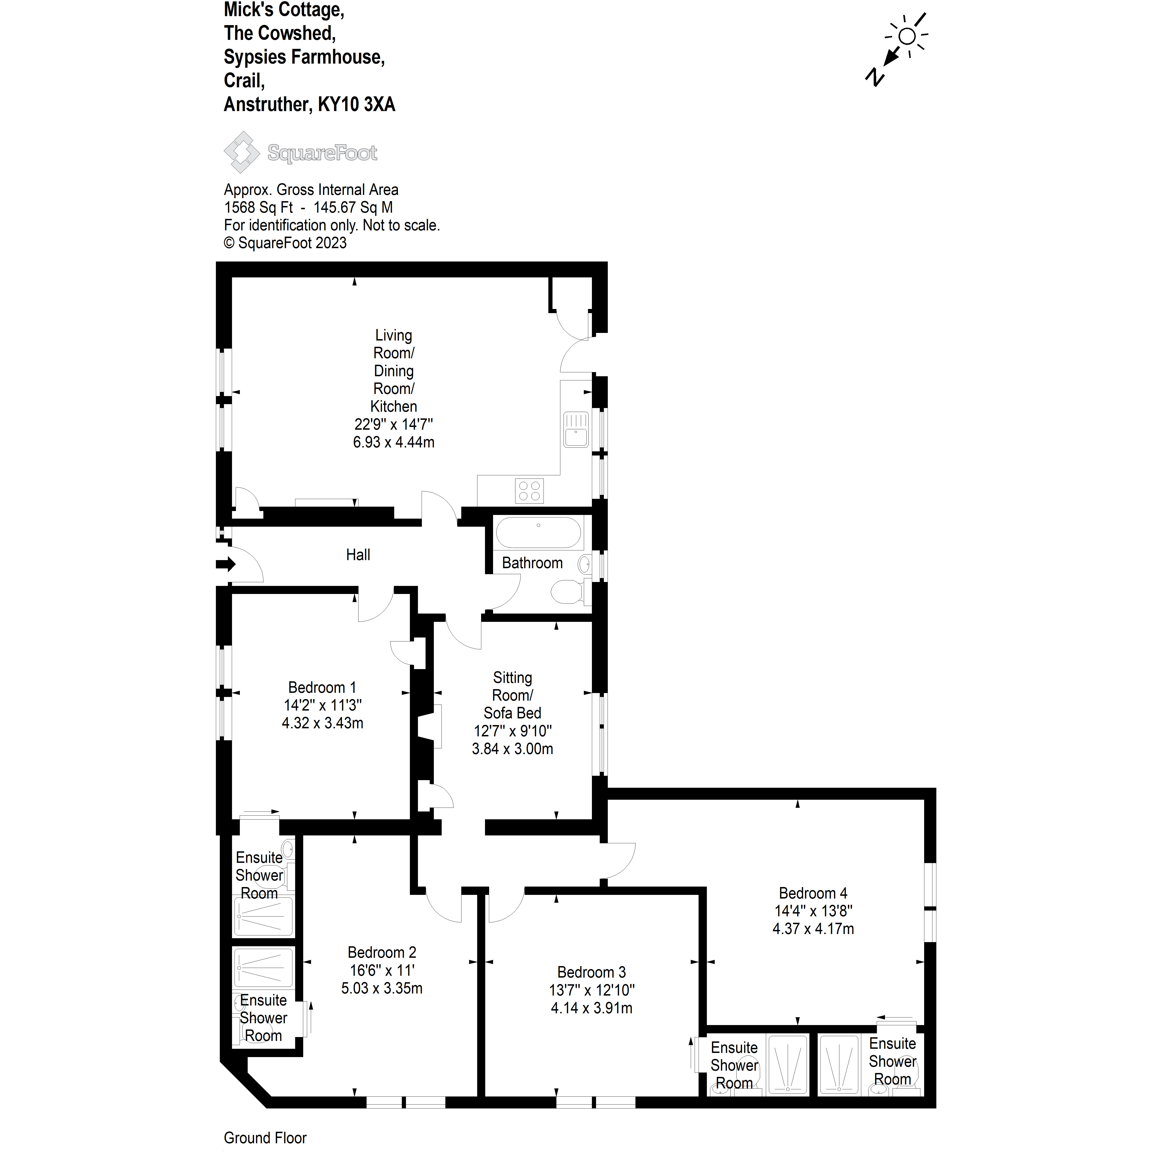

Kirkmay Cottages (10 minute walk/short drive):

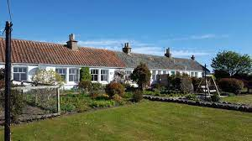

Kirkmay Cottage (not available from September 2025)

Sleeps 4 in one double room and one twin room
http://www.propertystandrews.co.uk/property-details/Kirkmay_Cottage_Crail-74025/

Nuttings Cottage

Sleeps 4 in one double room and one twin room
http://www.propertystandrews.co.uk/property-details/The_Nuttings_Cottage_Crail-74007/

May Isle Cottage

Sleeps 2 in one twin room
http://www.propertystandrews.co.uk/property-details/May_Isle_Crail-74027/

Kirkmay 4 Cottage

Sleeps 6 in two double rooms and one twin room
http://www.propertystandrews.co.uk/property-details/Kirkmay_4_Crail-74029/

Lairdsgate Cottage (not available from September 2025)

Sleeps 5 in one double room, one twin room and one single room
http://www.propertystandrews.co.uk/property-details/Lairdsgate_Crail-74031/

We advise couples to book the accommodation at the time of booking the venue. Availability of the accommodation is not guaranteed as the cottages are also advertised for holiday accommodation.

